A CRM APPLICATION FOR THE SUPPORTSPHERE SOLUTIONS

AI-Powered Customer Support & Service Automation for SupportSphere Solutions
User Story:
As a customer support representative at SupportSphere Solutions, I want to efficiently manage customer support requests and automate service operations using our AI-powered customer support application.
I want to easily create, track, update, and resolve customer support cases while maintaining complete customer information in Salesforce. The application should intelligently categorize support requests, prioritize urgent cases, and automatically assign them to the appropriate support agents, ensuring faster issue resolution.
Additionally, I need the system to automate repetitive support tasks such as case assignment, status updates, email notifications, and follow-up reminders, allowing the support team to focus on resolving customer issues more efficiently.
Moreover, I require AI-assisted recommendations that suggest possible solutions based on previous cases, helping support agents resolve customer problems accurately and quickly. The application should also generate interactive reports and dashboards that provide insights into case volumes, response times, resolution rates, and customer satisfaction, enabling management to make informed business decisions.
Finally, I would like the application to automatically notify customers about case creation, status updates, and issue resolution through email, ensuring transparent communication and improving the overall customer service experience.

INTRODUCTION
1.1:ProjectOverview
This project develops an AI-powered customer support and service automation system using Salesforce. It enables organizations to manage customer cases, automate repetitive support tasks, improve response times, and provide intelligent assistance using Salesforce automation features.
1.2:Purpose
The purpose of this project is to streamline customer support, improve service quality, automate workflows, ensure accurate data management, and provide actionable insights through reports and dashboards.
1.3 Functional Scope
The functional scope includes customer case management, AI-assisted case handling, automated notifications, case assignment, validation, reporting, dashboards, and workflow automation.
Objectives:
• Automate customer support
• Reduce manual work
• Improve response time
• Increase customer satisfaction
• Generate reports and dashboards
• Ensure accurate case management

2. IDEATION PHASE
PS | Customer | I'm Trying To | But | Because | Which Makes Me Feel
PS-1 | Customer | Get quick support for my issue | I have to wait a long time for responses | Support requests are handled manually | Frustrated and dissatisfied
PS-2 | Support Agent | Resolve customer issues efficiently | Repetitive questions consume time | There is no intelligent automation | Overworked and less productive
PS-3 | Support Manager | Monitor team performance and service quality | It is difficult to track case progress | Reports are generated manually | Uncertain about operational performance
PS-4 | Business Owner | Improve customer satisfaction | Customer complaints increase due to slow resolutions | Lack of automation and analytics | Concerned about customer retention

2.1 Problem Statement (Customer Problem Statement Template)

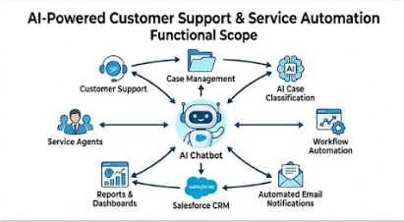
2.2 Empathy Map Canvas
Target Users
- Customers
- Customer Support Agents
- Support Managers
- Salesforce Administrators
- Business Analysts
Empathy Analysis :
Aspect | Description
Think & Feel | Need quick, accurate, and reliable customer support with minimal waiting time.
Hear | Customer complaints, management feedback, service quality expectations, and performance targets.
See | Large volumes of support tickets, repetitive customer issues, manual processes, and delayed responses.
Say & Do | Create support tickets, assign cases, update records, resolve issues, and communicate with customers.
Pain | Slow responses, repetitive manual work, inconsistent customer service, delayed issue resolution, and difficulty tracking support performance.
Gain | AI-powered automation, faster case resolution, intelligent recommendations, improved customer satisfaction, reduced manual effort, and real-time reporting.
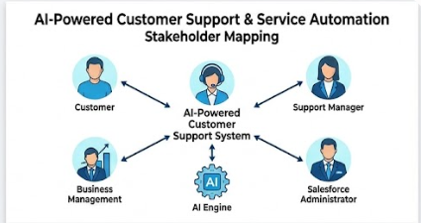
2.3 Brainstorming :
Brainstormed Ideas :
- Manual customer support system
- Email-based support management
- Excel-based ticket tracking
- Web-based help desk application
- Chatbot-based customer support
- Salesforce Service Cloud implementation
- AI-powered customer support automation using Salesforce

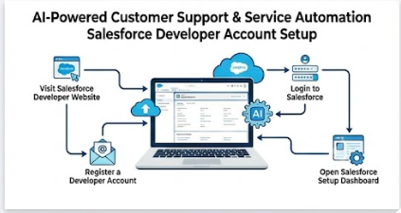
Selected Idea :
AI-Powered Customer Support & Service Automation using Salesforce
The selected solution integrates Salesforce with AI-powered automation to streamline customer support operations. The system enables intelligent case management, automated workflows, email notifications, AI-assisted recommendations, and interactive dashboards, improving service quality while reducing manual effort

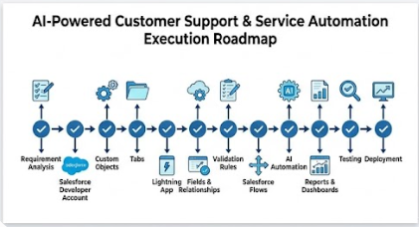
3. Stakeholder Mapping

Phase | Activity | Deliverable
1 | Salesforce Setup | Developer Org
2 | Requirement Analysis | Requirements
3 | Objects & Tabs | Data Model
4 | Fields & Relationships | Database Structure
5 | Validation Rules | Data Validation
6 | Flows | Automation
7 | Reports & Dashboards | Analytics
8 | Testing & Deployment | Final System

4. Execution Roadmap
Stakeholder | Role | Responsibility | Benefit
Customer | End User | Raise and track support cases | Quick resolutions
Support Agent | Service Executive | Resolve customer cases | Reduced workload
Support Manager | Manager | Monitor performance | Better productivity
Salesforce Admin | Administrator | Configure Salesforce | Reliable system
AI Engine | Automation | Suggest responses | Faster service

5. PROJECT PLANNING & SCHEDULING
5.1 Project Planning
The project followed an Agile-based development methodology to ensure systematic planning, efficient implementation, and continuous improvement throughout the development lifecycle. The project was divided into multiple milestones, with each milestone focusing on a specific component of the Salesforce application.
Initially, a Salesforce Developer Edition account was created to establish the development environment. After gathering the project requirements, custom objects were designed to manage customer support information, support cases, and service requests. Custom tabs and a Lightning Application were then developed to provide an organized and user-friendly interface.
Various custom fields and relationships were configured to store customer details, case information, priorities, and service status accurately. Validation rules were implemented to maintain data integrity and prevent incorrect data entry. Salesforce Flows were created to automate customer support processes such as case assignment, email notifications, and status updates.
AI-powered automation features were integrated to assist support agents by recommending solutions based on previous cases and automating repetitive support tasks. Finally, reports and dashboards were created to monitor support performance, case resolution time, customer satisfaction, and overall service efficiency.
The project was continuously tested during each sprint to identify and resolve issues before deployment. Regular progress reviews ensured that all project objectives were completed within the planned schedule.
Product Backlog, Sprint Schedule, and Estimation
Sprint | Functional Requirement (Epic) | User Story No. | User Story / Task | Story Points | Priority | Team Member
Sprint-1 | Environment Setup | USN-1 | As an administrator, I want to create a Salesforce Developer Account so that I can configure the AI-powered customer support system. | 2 | High | Member 1
Sprint-1 | Data Modeling | USN-2 | As an administrator, I want to create Customer and Support Case objects so that customer requests can be managed efficiently. | 5 | High | Member 2
Sprint-2 | Navigation | USN-3 | As a user, I want custom tabs for Customer and Support Case objects so that I can easily access records. | 3 | High | Member 3
Sprint-2 | Lightning App | USN-4 | As a support agent, I want a dedicated Lightning App so that I can perform all support from one place. activities | 3 | High | Member 4
Sprint-2 | Data Modeling | USN-5 | As an administrator, I want to create custom fields and relationships so that complete customer and case information can be stored. | 5 | High | Member 1
Sprint-3 | Validation | USN-6 | As a system, I want validation rules to prevent invalid customer information and incomplete support cases. | 4 | High | Member 2
Sprint-3 | Automation | USN-7 | As a system, I want Salesforce Flows to automatically assign support cases based on priority. | 5 | High | Member 3
Sprint-4 | Automation | USN-8 | As a system, I want automated email notifications to inform customers about case updates and resolutions. | 5 | High | Member 4
Sprint-4 | AI Integration | USN-9 | As a support agent, I want AI-powered solution recommendations so that customer issues can be resolved more quickly. | 5 | Medium | Member 1
Sprint-5 | Reports | USN-10 | As a manager, I want reports showing case status, priorities, and resolution time so that I can monitor team performance. | 4 | High | Member 2
Sprint-6 | Dashboards | USN-11 | As a manager, I want interactive dashboards to analyze customer support metrics and service efficiency. | 4 | Medium | Member 3
Sprint-6 | Testing & Deployment | USN-12 | As an administrator, I want to test and deploy the application so that users can access a stable and reliable support system. | 3 | High | Member 4

Project Tracker, Velocity & Burndown Chart
Sprint | Total Story Points | Duration | Sprint Start Date | Sprint End Date (Planned) | Story Points Completed | Sprint Release Date
Sprint-1 | 20 | 6 Days | Day 1 | Day 6 | 20 | Day 6
Sprint-2 | 20 | 6 Days | Day 7 | Day 12 | 20 | Day 12
Sprint-3 | 20 | 6 Days | Day 13 | Day 18 | 20 | Day 18
Sprint-4 | 20 | 6 Days | Day 19 | Day 24 | 20 | Day 24
Sprint-5 | 20 | 6 Days | Day 25 | Day 30 | 20 | Day 30
Sprint-6 | 20 | 6 Days | Day 31 | Day 36 | 20 | Day 36

Sprint Milestones :
- Sprint 1: Salesforce Environment Setup and Custom Object Creation
- Sprint 2: Tabs, Lightning App, Fields & Relationships
- Sprint 3: Validation Rules and Case Automation
- Sprint 4: Email Notifications and AI-Based Support Automation
- Sprint 5: Reports and Performance Analytics
- Sprint 6: Dashboards, Testing, and Final Deployment

Implementation
Milestone 1 - Salesforce developer account creation :
Activity 1: Creating Developer Account:
Creating a developer org in salesforce.
1. Go to https://developer.salesforce.com/signup
2. On the sign up form, enter the following details :
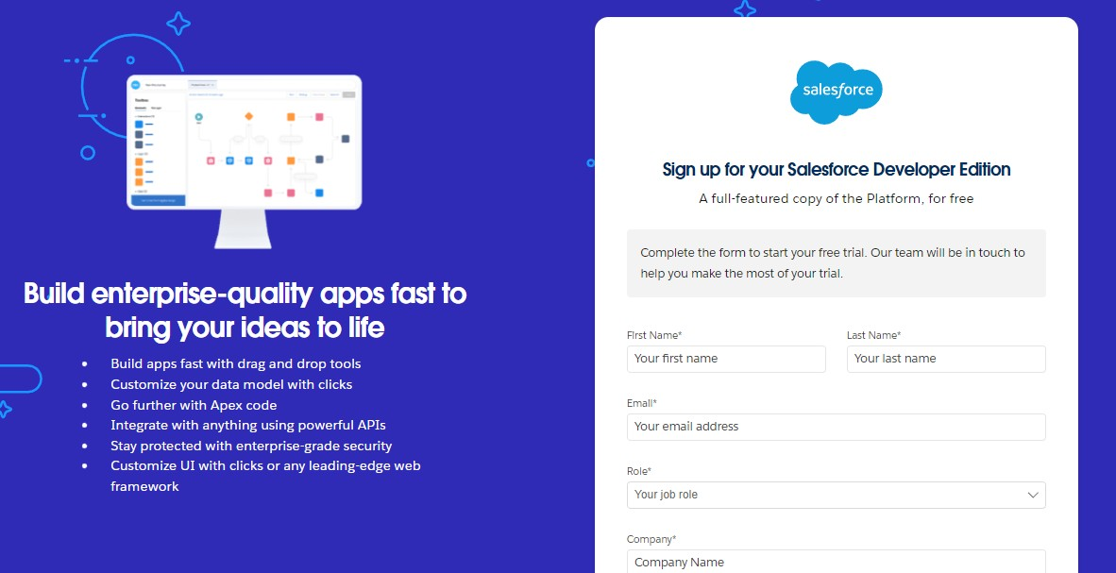
- First name & Last name
- Email
- Role : Developer
- Company : College or Company Name
- County : India
- Postal Code : pin code
- Username : should be a combination of your name and company
This need not be an actual email id, you can give anything in that format :
username@organization.com Click on sign me up after filling these.

Activity 2: Account Activation :

- Go to the inbox of the email that you used while signing up. Click on the verify account to activate your account. The email may take 5-10mins.

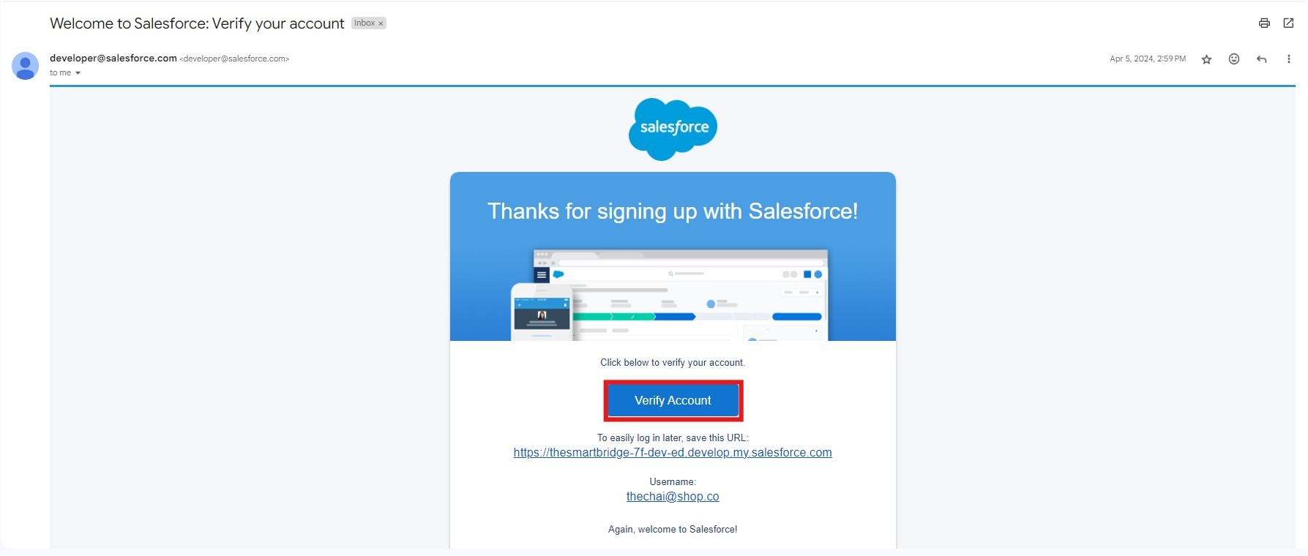

- Click on Verify Account.
- Give a password and answer a security question and click on change password.

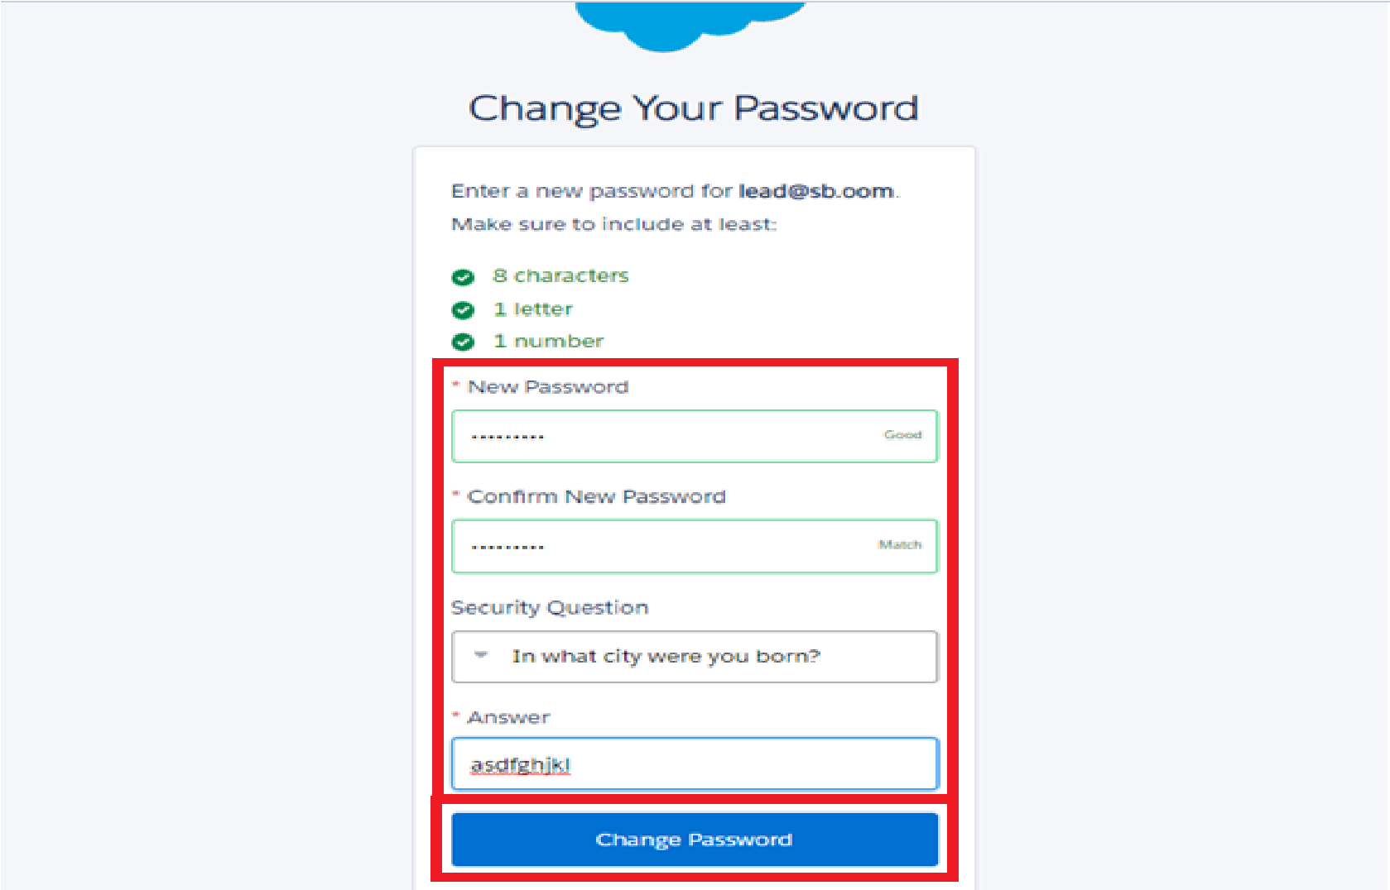

4. Then you will redirect to your salesforce setup page.
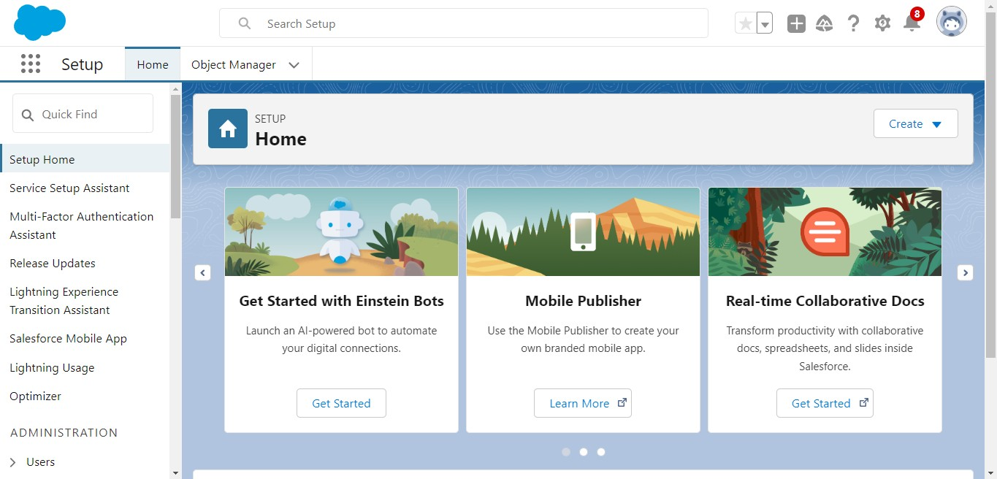

Milestone 2 - Objects

1.In your Salesforce org, click gear icon on the top left and select Setup to open Setup.
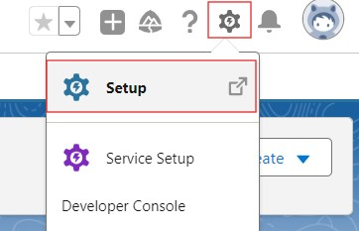

2.Click the Object Manager tab. If you don’t see it, enter Object Manager in the Quick Find box.
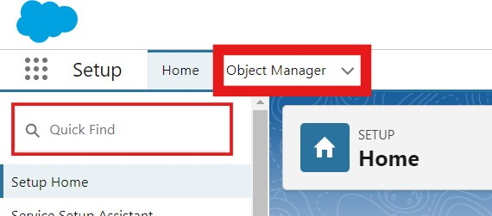
- On the Object Manager page, click Create | Custom Object.

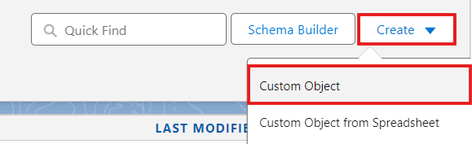

Activity 1 : Employer Account Object

1. From the setup page → Click on Object Manager → Click on Create → Click on Custom Object.
- Label : Employer Account
- Plural Label : Employer Accounts
- Enter Record Name Label and Format
  - Record Name : Employer Account Name
  - Data Type : Text
- In Optional features : check the boxes for Allow Reports | Allow Activities | Track Field History.
- Search Status : check the box for Allow Search.
- Save

Activity 2 : Customer Account Object

- From the setup page → Click on Object Manager → Click on Create → Click on Custom Object.
- Label : Customer Account
- Plural Label : Customer Accounts
- Enter Record Name Label and Format
        - Record Name : Customer Account Name
        - Data Type : Text
- In Optional features : check the boxes for Allow Reports | Allow Activities | Track Field History.
- Search Status : check the box for Allow Search.
- Save

Activity 3 : Enterprise Account Object

- From the setup page → Click on Object Manager → Click on Create → Click on Custom Object.
- Label : Enterprise Account
- Plural Label : Enterprise Accounts
- Enter Record Name Label and Format
        - Record Name : Enterprise Account Name Data Type : Text
- In Optional features : check the boxes for Allow Reports | Allow Activities | Track Field History.
- Search Status : check the box for Allow Search.
- Save

Milestone 3 - Tabs Creation

Activity 1 : Custom tabs creation
- Go to setup page → type Tabs in Quick Find bar → click on tabs → New (under custom object tab)
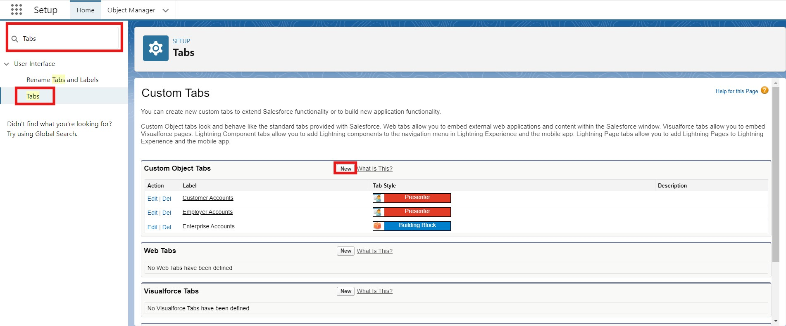
- Select Object(Employer Accounts) → Select the tab style → Next (Add to profiles page) keep it as default → Next (Add to Custom App) uncheck the include tab .
- Make sure that the Append tab to users' existing personal customizations is checked.
- Click save.
- Repeat the same steps for Customer Accounts and Enterprise Accounts.

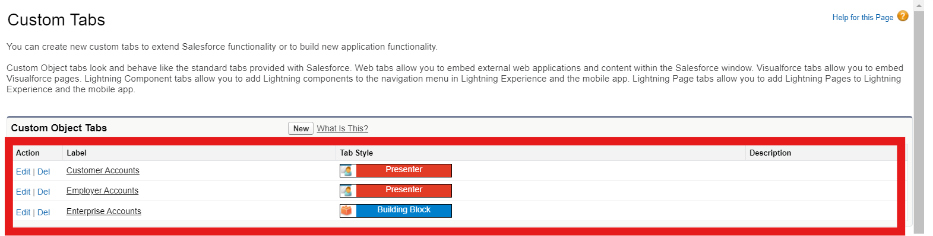

Milestone 4 – Field and Relations

Activity 1 : Creating Custom Object Fields
Table 1: Customer__c Object Fields:
Field Label | Data Type
Customer Name | Text
Email | Email
Phone | Phone
Customer Type | Picklist(Individual, Business)
Table 2 : Merchandise Object Fields:
Field Label | Data Type
Product Name | Text
Product Code | Text
Category | Picklist
Warranty (Months) | Number
Active | Checkbox

Table 3 :Orders__c Object Fields:
Field Label | Data Type
Order Number | Auto Number
Order Date | Date
Status | Picklist(New, Shipped, Delivered)
Customer | Lookup(Customer)
Product | Lookup(Product)

Table 4 : User Cases Object Fields:
Field Label | Data Type
Product | Lookup(Product)
Order | Lookup(Order)
Priority | Picklist(Low, Medium, High)
Issue Category | Picklist(Delivery, Damage, Warranty)
AI Summary | Long Text Area

Milestone 5 : Validation Rules On User Object

Activity 1: Validation Rules on User Case Object :

Step 1 : Click Setup Navigate to Object Manager Select : User Case

Step 2: Open Validation Rules Inside Case object settings, click Validation Rules Click New
Step 3: Enter Rule Details Rule Name: Damage_Requires_Priority Description: Ensures Damage requires to case is high.

Step 4: Enter the Validation Formula Paste the following formula: AND( ISPICKVAL(Case_Type__c, "Damage"), ISBLANK(TEXT(Priority__c)) )

Step 5: Add Error Message Error Message: Priority is mandatory for Damage cases. Error Location: Field → Priority Step
6: Save

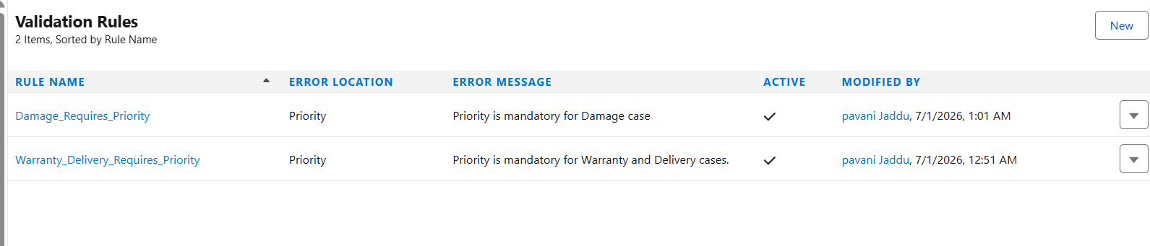

Activity 2 : Validation in User Case :
Step 1 : Click Setup Navigate to Object Manager Select: User Case

Step 2: Open Validation Rules Inside Case object settings, click Validation Rules Click New

Step 3: Enter Rule Details Rule Name:Warranty_Delivery_Requires_Priority Description: Ensures Damage requires to case is high.

Step 4: Enter the Validation Formula Paste the following formula: AND( OR( ISPICKVAL(Case_Type__c, "Warranty"), ISPICKVAL(Case_Type__c, "Delivery") ), ISBLANK(TEXT(Priority__c)) )

Step 5: Add Error Message Error Message:Priority is mandatory for Warranty and Delivery cases Error Location: →Top of Page Step 6: Save

Milestone : 6 Flows

Activity 1 : Creating Record Triggering Flow
Go to Setup Search for Flows Click New Flow

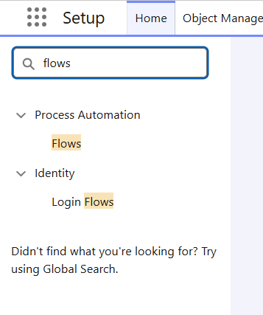
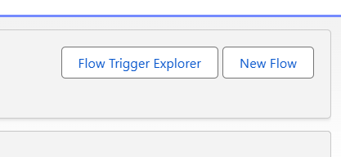

Select Record-Triggered Flow
Click Create Object > User Case Configure Trigger>Trigger the Flow
When: A record is created or updated
Set Entry Conditions : None Actions and Related Records : Selected

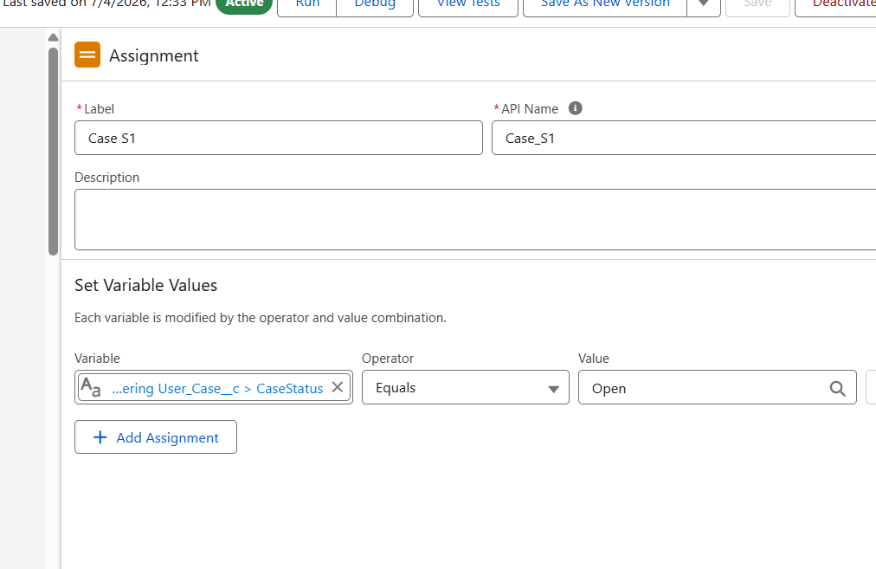

- Click ➕ Add Element
- Select: Assignment Label: Case S1
- API Name : Auto populate
- Set Variable Values
- Variable>CaseStatus
- Operator>Equals Value>Open
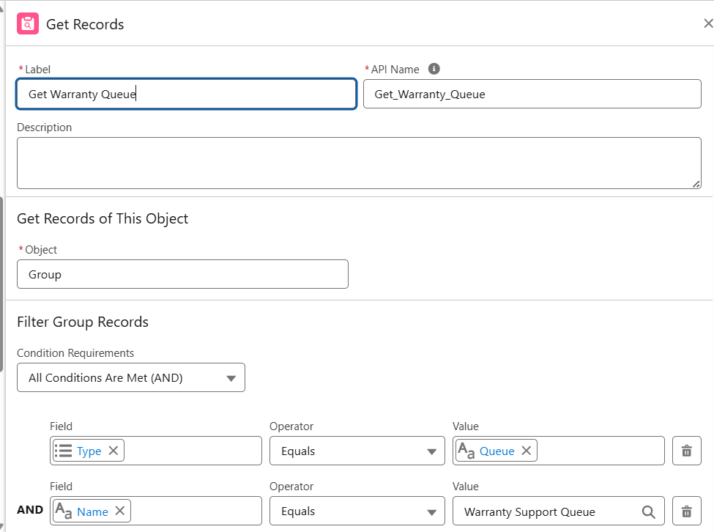

- Click ➕ Add
- Element Select : Decision
- Label : Check Case Type
- Api Name : Auto Populated Outcome Details Outcome
- Label : Damage Case
- Resource : User_Case_c > Case Type
- Operator : Equals Value > Damage
- Outcome Label 2
- Lablel : Warranty Case
- Resource : User_Case_c > Case Type
- Operator : Equals
- Value > Warranty

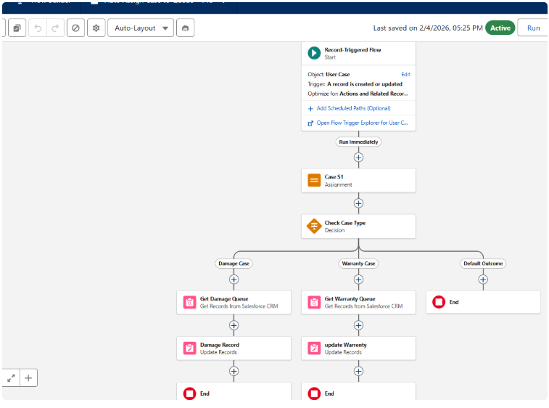

Activity 2 : Creating Queues Damage Support Queue
Go to Setup Search for Queues Click New Enter: Label : Damage Support Queue Queue Name : Damage_Support_Queue Supported Objects : Available Objects > Select> user cases Selected Objects> user cases Queue Members> user create
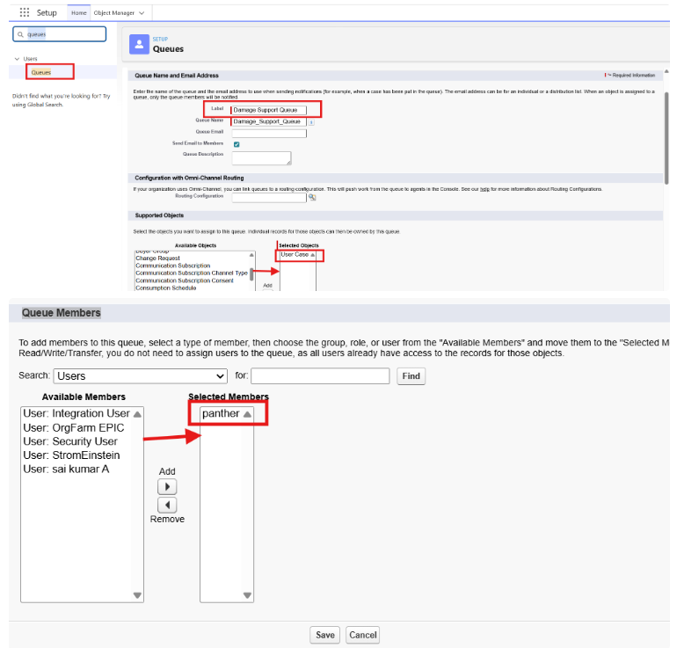

Queues Warranty Support Queue
Go to Setup Search for Queues Click New Enter: Label : Warranty Support Queue Queue Name : Warranty Support Queue Supported Objects : Available Objects > Select> user cases Selected Objects> user cases Queue Members> user created
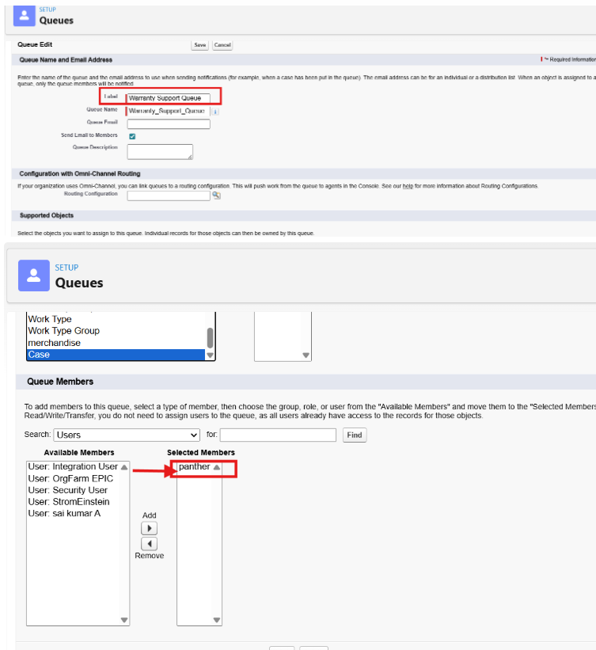

Activity 3 : Creating Recording Triggering Flow
Go to Setup
Search for Flows


Click New Flow



Select Record-Triggered Flow
Click Create
Object > User Case

Trigger the Flow When:>A record is created
Optimize the Flow for: > Actions and Related Records
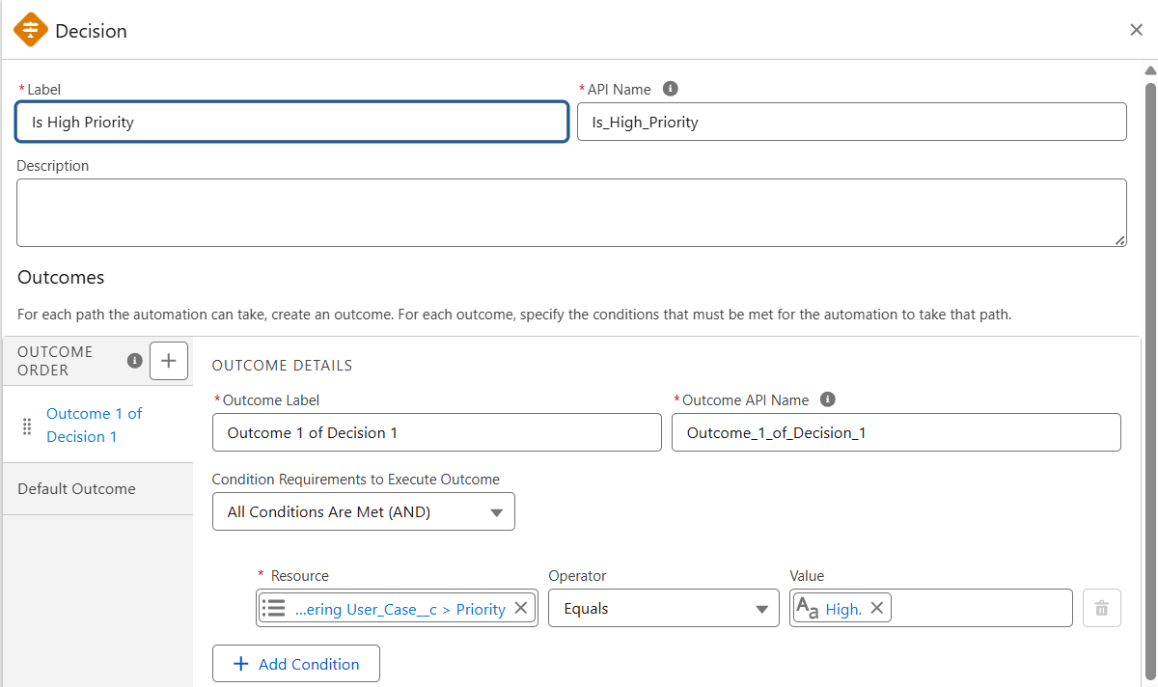

Click ➕ Add Element
Label : Is High Priority
Outcome Details
*Outcome Label : Outcome 1 of Decision 1
Fields>{!$Record.Priority__c}>Equals >High
Click ➕ Add Element Under Outcome 1 of Decision 1
CLICK > Update Records
Set Field Values for the User Case Record
Field> OwnerID> 3D00Gfj000007Qgyr copy the user case url page of record id
Save >Case Auto Assignment & SLA Flow
and> Activate

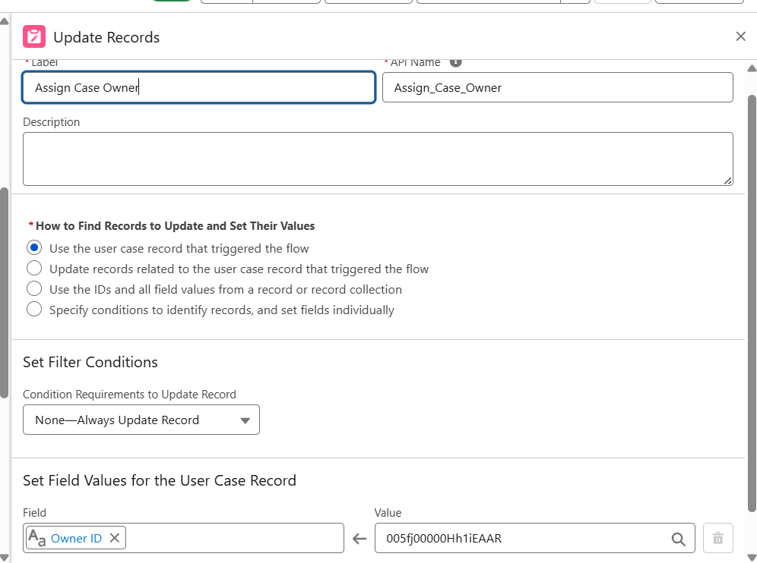

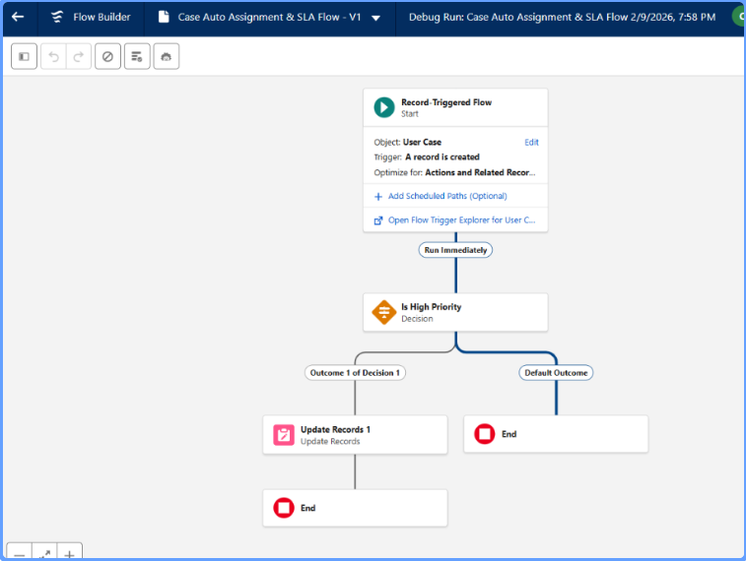

Milestone 7 : Lightning App
Activity 1: Create a Lightning App
To create a lightning app page:
- Go to setup page → search “app manager” in quick find → select “app manager” → click on New lightning App.
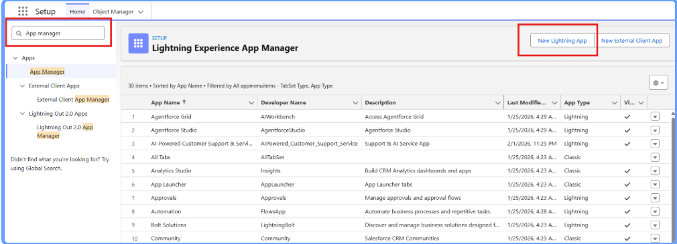

- Fill the app name in app details and branding as follow
App Name : AI-Powered Customer Support & Service Automation
- Developer Name : this will auto populated
Description:Give a meaningful description
Image : optional (if you want to give any image you can otherwise not mandatory)
Primary color hex value : keep this default
- Then click Next → (App option page) keep it as default → Next → (Utility Items) keep it as default → Next.
- To Add Navigation Items:
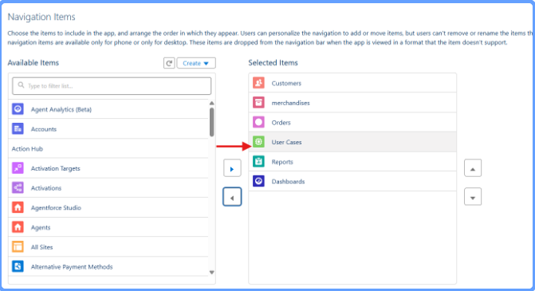

- Search the items in the search bar and move it using the arrow button → Next.
Note: select the custom object which we have created in the previous activity.

- To Add User Profiles:

Milestone 8 : Create Prompt Template :

- Step 1: Enable Einstein (AgentForce)
- Click the Gear Icon → Select Setup.
- In the Quick Find box, search Einstein Setup.
- Click Einstein Setup.
- Enable Turn on Einstein.
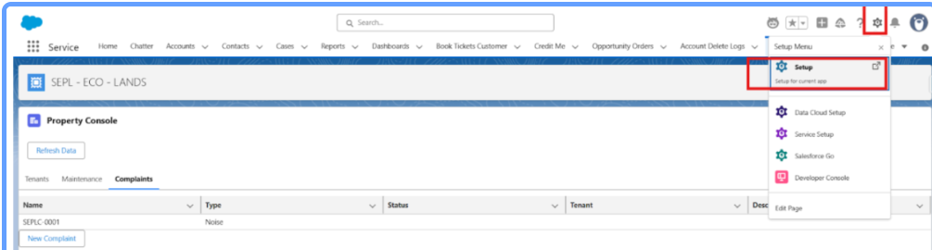

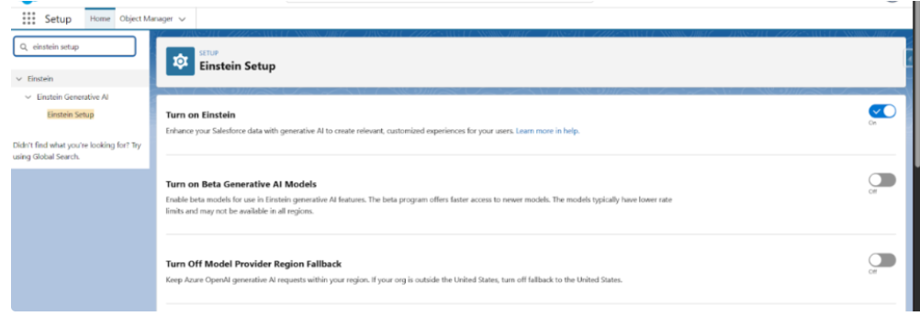

- Refresh the page after enabling Einstein.
- Prerequisite: Create AI Summary Field
- Before selecting the field in Prompt Builder, you must create the Performance Summary field in the Student object.
- Steps:
- Click Gear Icon → Setup.
- In Quick Find, search Object Manager.
- Select Student__c.
- Click Fields & Relationships → New.
- Select Long Text Area → Click Next.
- Field Label: Ai Summary
- API Name auto-populates as i Summary_c
- Set Length = 32000 and Visible Lines = 5–10.
- Click Next → Save.

Step 2: Open Prompt Builder
- In the Quick Find box, search Prompt Builder.
- Click Prompt Builder.
- Click New Prompt Template.
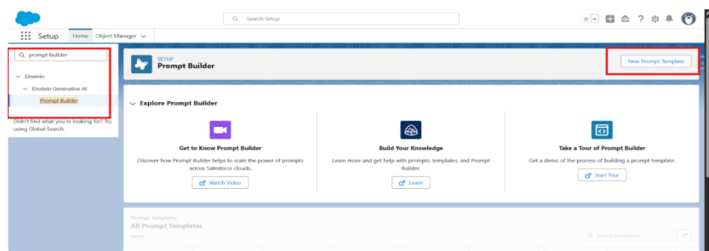

Step 3: Select Prompt Type
- Choose Field Generation.

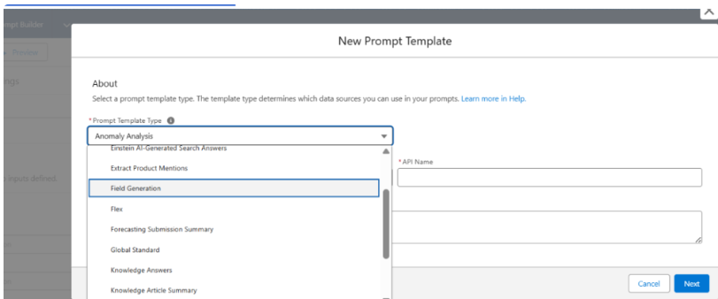

Step 4: Enter Details
Label Name: MetaDataInspection
API Name auto-populates.
Object: User Case
Field: Ai Summary

Step 5: Insert Resources
- Click Insert Resources.
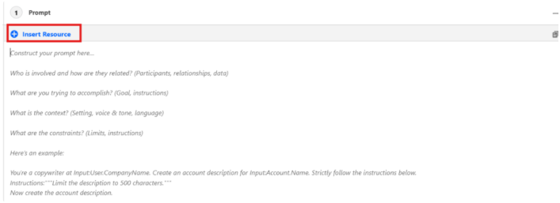

Select User Case object.
Choose fields such as:
{!$Input:User_Case__c.Name}
{!$Input:User_Case__c.CreatedDate}
{!$Input:User_Case__c.Status__c}
- Paset this Prompt under Fields : Generate a clear and professional inspection summary using the provided inspection details. Explain the inspection status, inspection date, and key observations. Ensure the summary is easy to understand and suitable for business users.
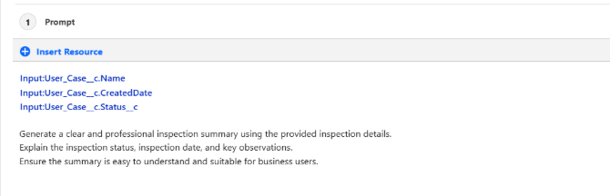
Step 7: Save and Activate
- Click Save.
- Click Activate
- Your Prompt Template is now ready.

Milestone 9 : Deploy Prompt Builder in Student Object Using Lightning App Builder

Step 1: Open Student Record
- Click the App Launcher (9 dots).
- Search user case .
- Open any existing Student Record.
Step 2: Edit Lightning Page
- Click the Gear Icon → Select Edit Page.
Step 3: Upgrade to Dynamic Detail Page
- Click the Detail Page.
- Click Upgrade Now.

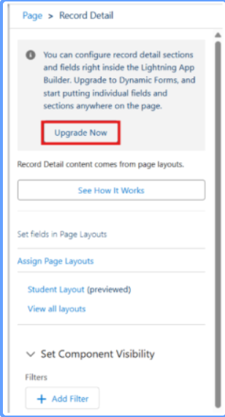
Click Next.
Select the User Case Layout.
Click Finish.
Step 4:
- Assign the Prompt Template to the Field
- Click the Ai Summary field on the layout.
- In the right-side panel, search Prompt Template.
- Select your template: MetaDataInspect.

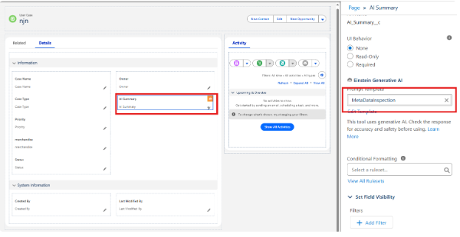

Step 5:
- Save & Activate the Page
- Click Save.
- Click Activate.
- Select Assign as Org Default.
- Choose Desktop and Phone.
- Click Next.
- Click Save.
- Click Back.

6 WORKING OF THE APPLICATION
6.1 Overview
The AI-Powered Customer Support & Service Automation application is developed on the Salesforce Lightning Platform to automate customer service operations and improve customer relationship management. The application provides an easy-to-use interface where users can manage customers, merchandise, support users, customer orders, reports, and dashboards from a single Lightning App.
The following steps demonstrate the complete workflow of the application.

Step 1: Launch the Lightning Application
After logging into Salesforce, click on the App Launcher located at the top-left corner of the Salesforce Lightning page.
Search for AI-Powered Customer Support & Service Automation and open the Lightning Application.
The application displays all custom tabs such as:
- Customers
- Merchandise
- Users
- Orders
- Reports
- Dashboards
This provides a centralized workspace for managing all customer support activities.

Step 2: Creating a Customer Record
Select the Customers tab from the navigation menu.
Click the New button to create a customer record.
Enter the required information:
- Customer Name
- Email Address
- Phone Number
- Address
- Customer Type
- Registration Date
After entering all mandatory details, click Save.
The customer record is successfully stored in Salesforce.

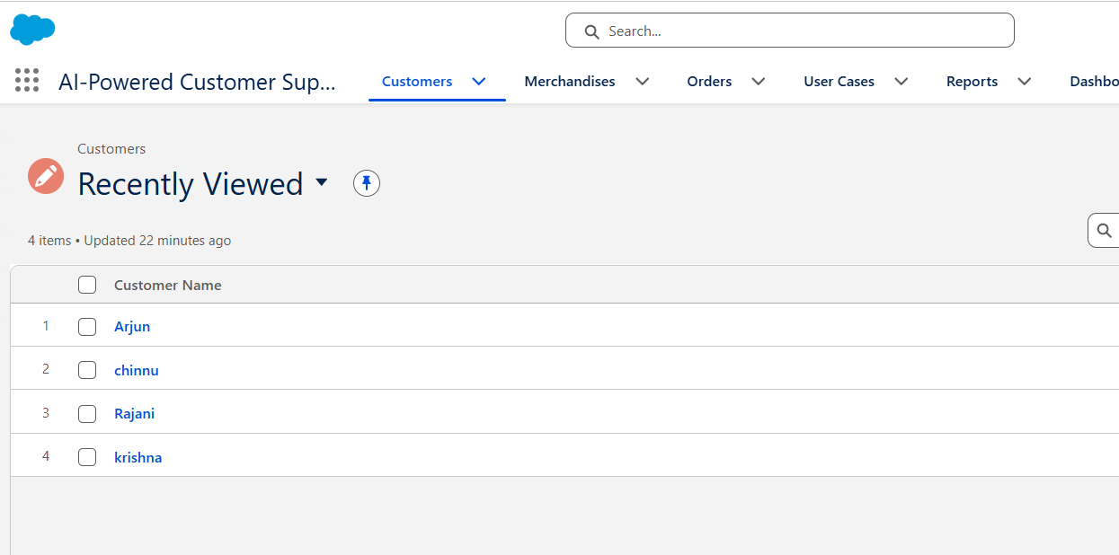

Step 3 :Navigate to the Merchandise tab.
Click New.
Enter merchandise details such as:
- Merchandise Name
- Category
- Product Description
- Unit Price
- Available Quantity
- Status
Click Save to store the merchandise information.
The merchandise records will later be available while creating customer orders

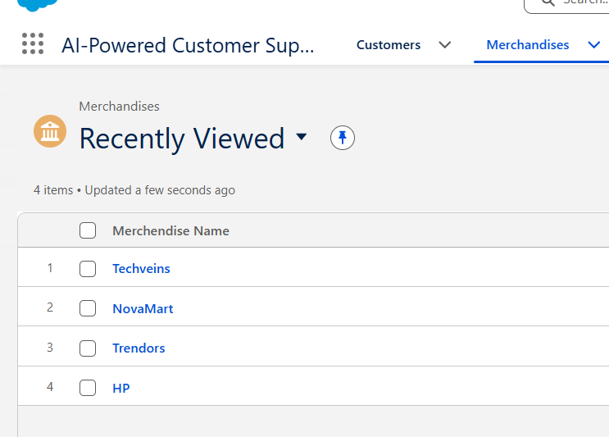

Step 4 :Open the User case
Click New.
Enter user information including:
- User case Name
- Employee ID
- Email Address
- Phone Number
- Department
- Designation
Click Save.
The new support user is now available to manage customer service requests.

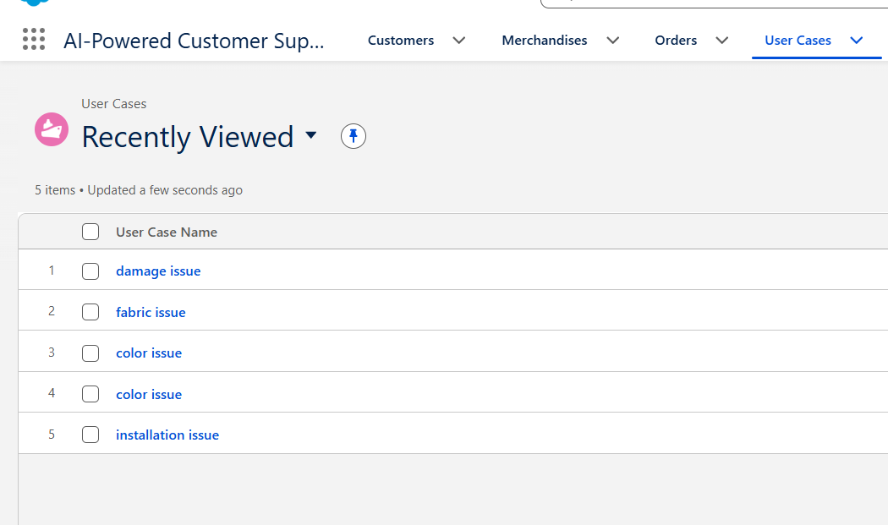

Step 5 : Navigate to the Orders tab.
Click New.
Select the customer from the existing customer records.
Choose the required merchandise items.
Enter the order information:
- Order Number
- Customer Name
- Merchandise
- Quantity
- Order Date
- Order Status
Save the order.

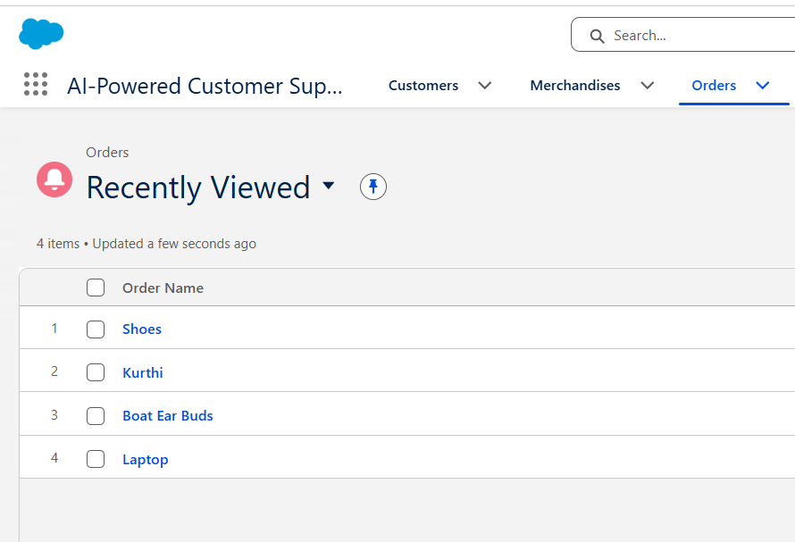

Step 6: Validation Rules
When the user attempts to save a record, Salesforce automatically validates all mandatory fields.
If incorrect or incomplete information is entered, validation rules display appropriate error messages.
Examples include:
- Empty required fields
- Invalid phone number
- Incorrect email format
- Missing order information
These validations ensure accurate and reliable data.

Step 7: Flow Automation
Once an order or customer support record is created, Salesforce Flow executes automatically.
The flow performs predefined automation such as:
- Updating record status
- Assigning support requests
- Sending email notifications
- Triggering follow-up actions
Automation reduces manual effort and improves operational efficiency.

Step 8: AI Support using Prompt Builder
The application uses Salesforce Prompt Builder to provide AI-generated responses.
Based on customer details and order information, the AI generates:
- Customer support summaries
- Suggested responses
- Case recommendations
- Automated service assistance
This helps support agents resolve customer queries quickly.

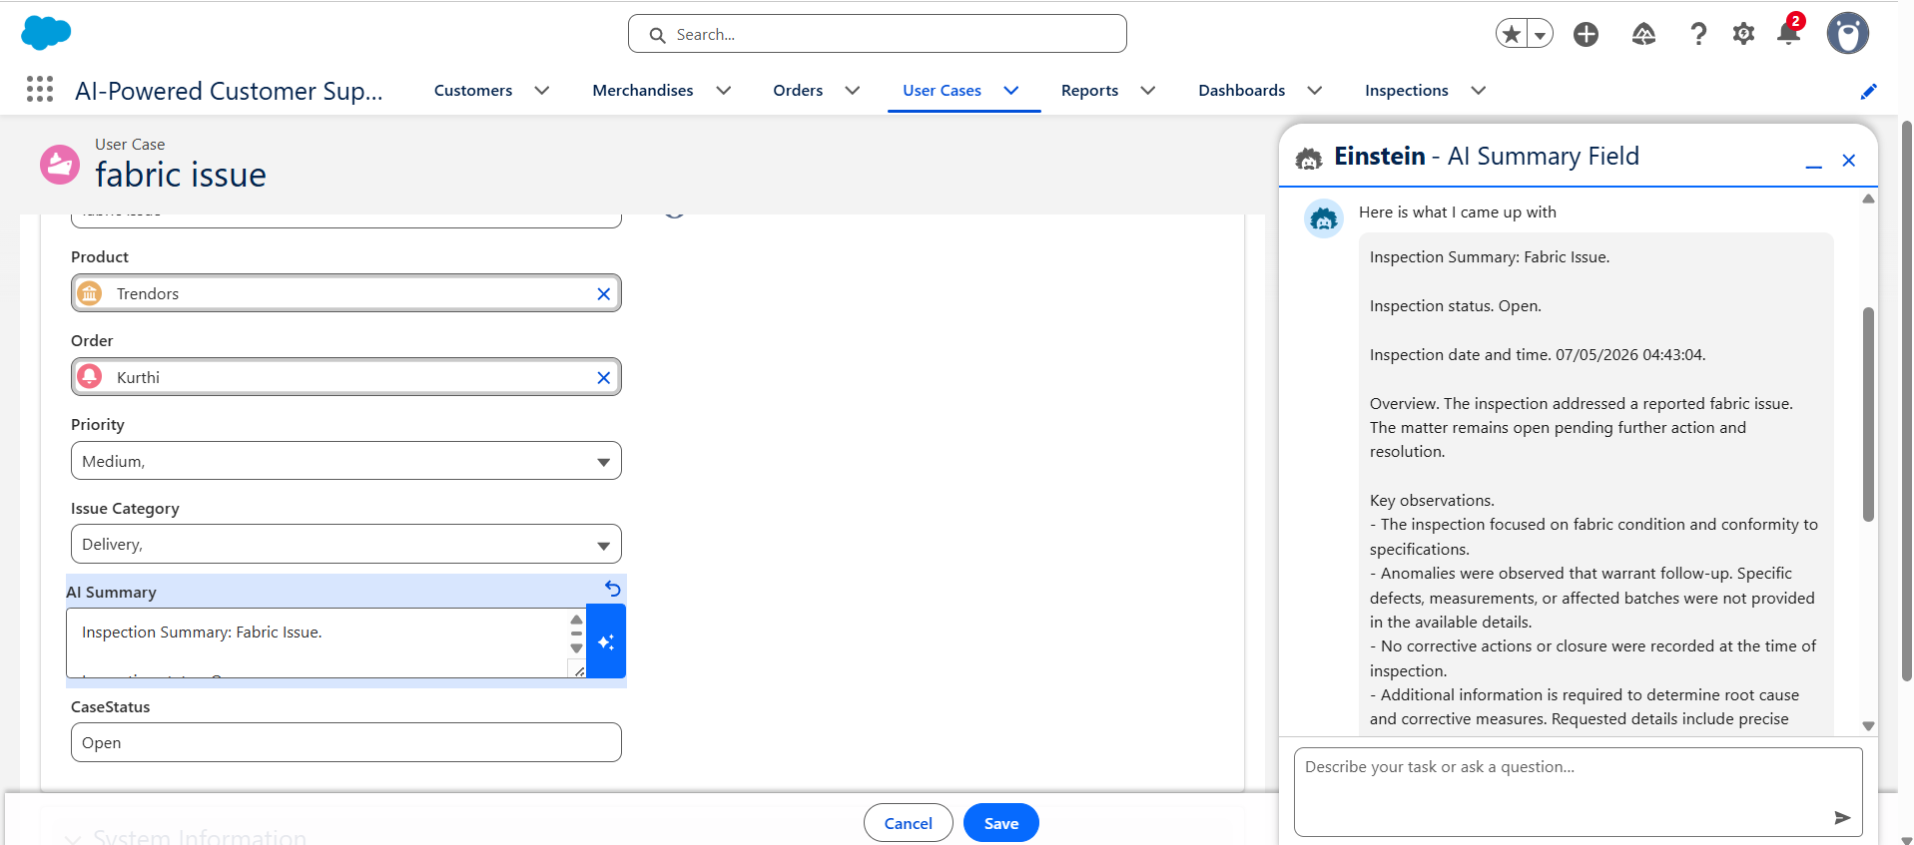

Step 9: Reports
Open the Reports tab.
The application generates reports showing:
- Customer Details
- Merchandise Details
- User Information
- Order Summary
- Sales Performance
- Customer Service Activity
These reports help management analyze business performance.

Step 10: Dashboards
Navigate to the Dashboards tab.
The dashboard displays graphical summaries including:
- Total Customers
- Total Merchandise
- Total Users
- Total Orders
- Open Support Requests
- Closed Requests
- Monthly Performance
- Customer Growth
Interactive charts help management monitor the application's overall performance.

Step 11: Record Management
Users can search, edit, update, and delete existing records whenever necessary.
The application maintains all customer, merchandise, user, and order information in a centralized Salesforce database.
This enables quick access to business information and improves productivity

Step 12: Application Completion
After all operations are completed, the user can verify reports and dashboards to ensure that all records have been processed successfully.
The AI-Powered Customer Support & Service Automation application successfully integrates customer management, merchandise management, user management, order processing, workflow automation, and business analytics into a single Salesforce Lightning Application.

9. FUNCTIONAL & PERFORMANCE TESTING
Functional Testing
Functional testing was carried out to ensure that all modules of the AI-Powered Customer Support & Service Automation application functioned according to the specified requirements. Each feature was tested individually and as part of the complete workflow.
The following functionalities were successfully tested:
- Creation and management of Customer records.
- Creation and management of Merchandise records.
- Creation and management of User records.
- Creation and management of Order records.
- Validation Rules for mandatory fields and invalid data.
- Salesforce Flow automation for business processes.
- AI-generated responses using Salesforce Prompt Builder.
- Navigation through the Lightning Application.
- Report generation for customer and order information.
- Dashboard visualization using charts and performance metrics.
All modules performed successfully without affecting the integrity of the application.

Performance Testing
Performance testing was conducted to evaluate the application's responsiveness, stability, and overall efficiency under normal operating conditions.
The application demonstrated the following performance characteristics:
- Fast record creation and retrieval within the Salesforce Lightning Platform.
- Quick execution of Salesforce Flows with minimal processing delay.
- Accurate generation of AI-assisted responses using Prompt Builder.
- Efficient loading of Reports and Dashboards.
- Reliable handling of customer, merchandise, user, and order records.
- Consistent application performance during continuous user operations.
- Stable execution without data loss or system failures during testing.
The results confirmed that the application meets the required performance standards for efficient customer support and service automation.

10. ADVANTAGES & DISADVANTAGES
Advantages
- Automates customer support processes, reducing manual effort.
- Provides centralized management of customers, merchandise, users, and orders.
- Improves response time through Salesforce Flow automation.
- Enhances customer service with AI-generated recommendations using Prompt Builder.
- Ensures data accuracy through Validation Rules.
- Simplifies navigation with a user-friendly Lightning Application.
- Generates real-time Reports and Dashboards for effective decision-making.
- Increases operational efficiency and staff productivity.
- Scalable architecture that can support future business growth.
- Improves overall customer satisfaction through faster and more consistent service.
Disadvantages
- Requires a Salesforce license for production deployment.
- Depends on a stable internet connection.
- Initial Salesforce configuration requires technical expertise.
- AI-generated suggestions may require manual verification in complex cases.
- Customizations can increase maintenance effort over time.
- Integration with external systems may require additional development.
- Large-scale implementations may involve higher operational costs.

11. CONCLUSION

The AI-Powered Customer Support & Service Automation application was successfully developed using the Salesforce Lightning Platform to modernize and automate customer service operations. The system effectively integrates customer management, merchandise management, user management, order processing, workflow automation, AI-powered assistance, reports, and dashboards into a unified application.
By leveraging Salesforce features such as Custom Objects, Lightning App Builder, Validation Rules, Salesforce Flows, and Prompt Builder, the application minimizes manual work, improves data accuracy, and enhances the efficiency of customer support activities. Automated workflows reduce processing time, while AI-assisted recommendations enable support agents to provide faster and more effective resolutions.
The generated Reports and Dashboards offer valuable insights into operational performance, helping management monitor business activities and make informed decisions. Overall, the application improves productivity, strengthens customer relationships, and demonstrates how Salesforce AI capabilities can be applied to build an intelligent and scalable customer support solution.

12. FUTURE SCOPE
The application can be further enhanced by implementing the following features:
- Integration with WhatsApp, SMS, and social media support channels.
- AI-powered sentiment analysis for customer interactions.
- Voice-based customer support using conversational AI.
- Mobile application for customers and support agents.
- Integration with third-party CRM and ERP systems.
- Predictive analytics for identifying customer issues before escalation.
- Real-time chatbot support using generative AI.
- Multi-language customer support.
- Advanced analytics with customizable dashboards.
- Cloud-based deployment for large-scale enterprise environments.

11. APPENDIX
Source Code:
- Salesforce Configuration
- Custom Objects
- Custom Fields & Relationships
- Validation Rules
- Salesforce Flows
- Lightning Application Configuration
- Salesforce Prompt Builder Configuration
Dataset:
- Customer Records
- Merchandise Records
- User Records
- Order Records
- AI-Generated Customer Support Data
- Reports and Dashboard Data
Tools Used:
- Salesforce Developer Edition
- Salesforce Lightning Experience
- Lightning App Builder
- Object Manager
- Flow Builder
- Prompt Builder
- Reports & Dashboards
- Web Browser (Google Chrome / Microsoft Edge)
Technologies Used:
- Salesforce CRM
- Salesforce AI (Prompt Builder)
- Flow Automation
- Lightning Framework
Development Environment:
- Salesforce Developer Org
- Windows Operating System
- Internet Connectivity

THANK YOU

